CS 340 Project 2 README

About the Project/Project Title
Project 2:
This project builds off of Project 1 in which I created a database with authorized access for a user to be able to carry out CRUD (create, read, update, and delete) functionalities. With this project specifically I developed an interactive dashboard that has access to the previously created database and allows the user to search the database based on specified criteria in a drop-drown menu and display the results of the search in a visual way (through graphs and maps).

Motivation
The purpose of this project is to create an interactive dashboard for Grazioso Salvare that enables them to search for specific dogs from the Austin Animal Center Outcomes dataset that would be good candidates for search-and-rescue training. The dashboard allows the user to select the specific type of search-and-rescue service (Water Rescue, Mountain or Wilderness Rescue, Disaster or Individual Tracking) in which they need a specific dog (based on their breed, sex, and age), and find which dogs are available.

Getting Started
Import the aac_shelter_outcomes csv file with the animals collection into MongoDB terminal.
Create a user with the name “aacuser” and select a password, and give this user the read/write role.
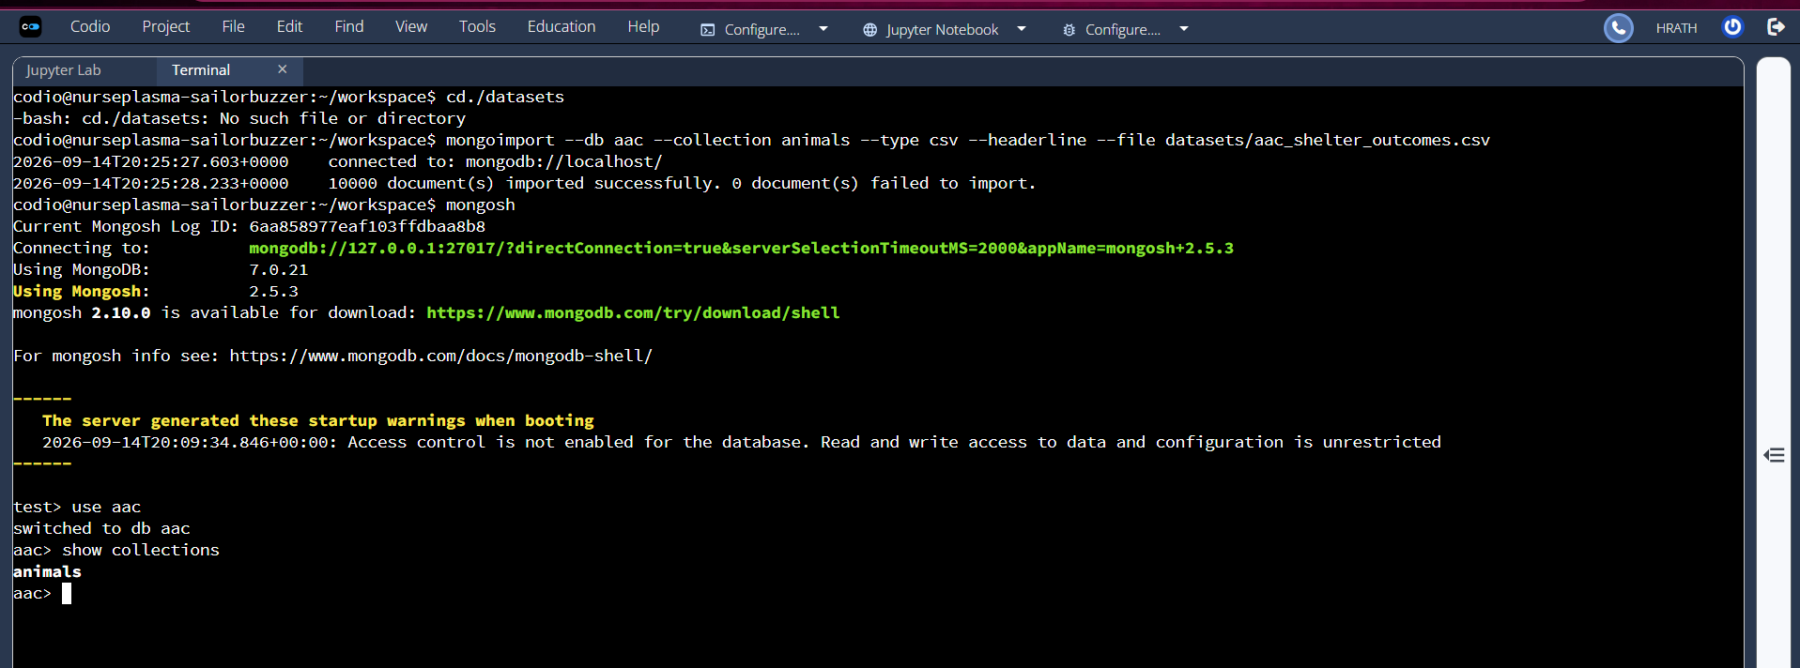
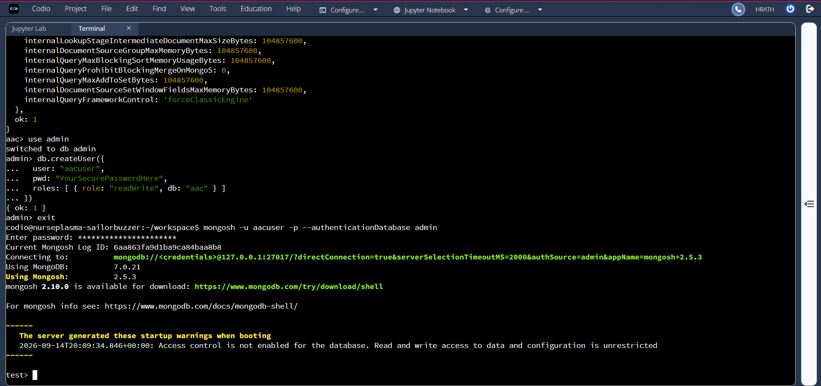

Create a Python module that has access to the aac database with the aacuser and enables CRUD functionality:
Set up access to the MongoDB aac database with the username, password, host, port, database, and collection
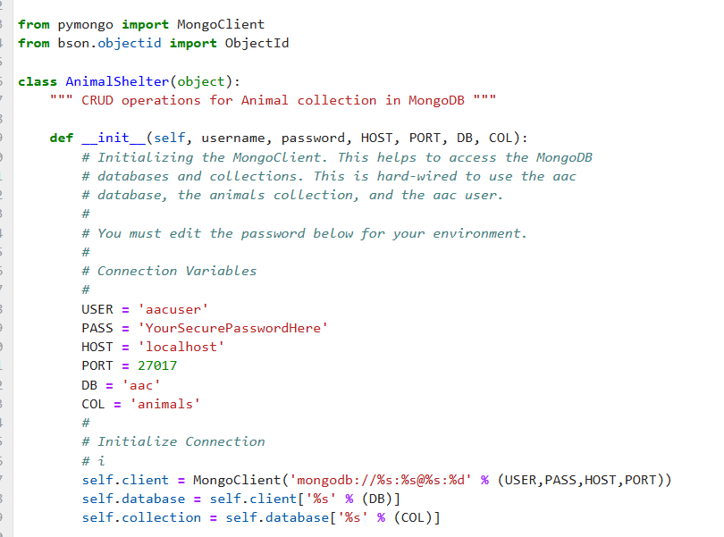

Set up the create functionality
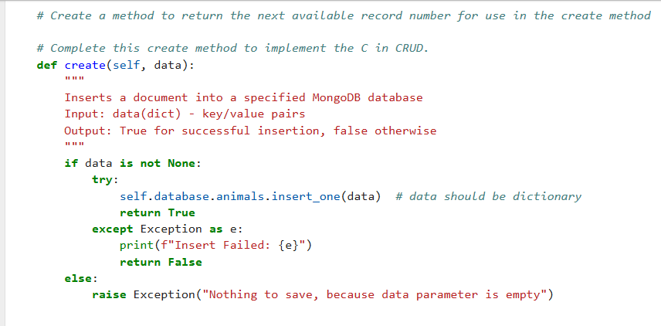

Set up the read functionality
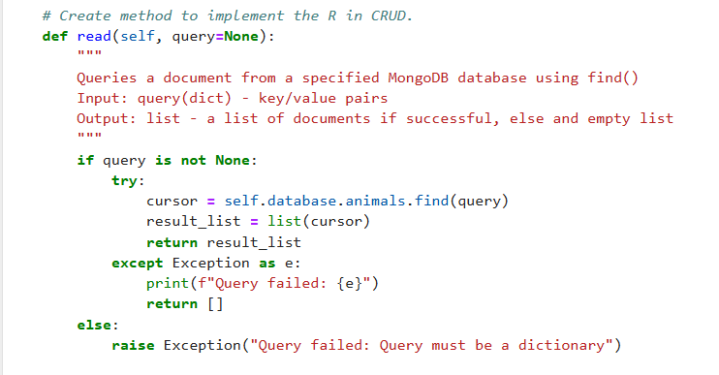

Set up the update functionailty
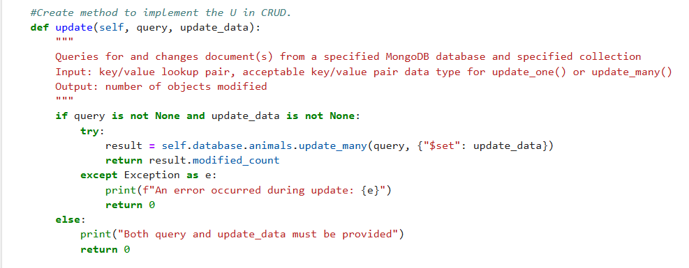

Set up the delete functionality
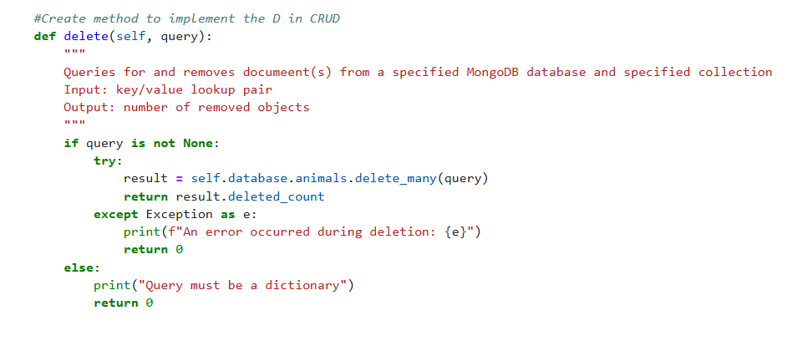

Tools and Technologies Used
- MongoDB - Used as the Model (Database) layer. MongoDB's NoSQL document-oriented structure was selected because it naturally stores large volumes of flexible, JSON-like animal profile records. This enables fast, scalable query execution when running specialized data filters.
- Python IDE - A reusable backend interface from Project One, integrated into this application to safely manage CRUD operations against the database.
- Jupyter Notebook - Utilized as the primary execution environment to integrate, orchestrate, and test backend modules to the front-end functionalities.
- Dash – Provides interactive functionality and visualizations for the web interface.
https://dash.plotly.com/dash-core-components

Dashboard Code
Import Python modules to enable Dash components. Connect to Python CRUD module to allow access through the aacuser including the username, password, host, port, database, and collection
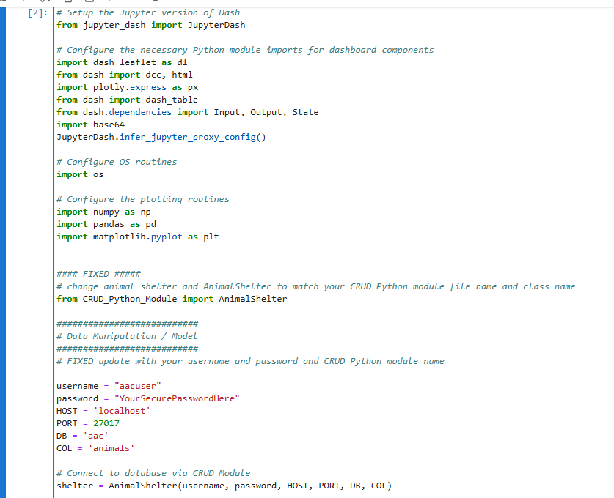

Set up the homepage with the company’s logo, name, and titles for the website. I added functionality in which when on the homepage, if you click the company’s logo, it will take you to their website using href.
https://dash.plotly.com/dash-html-components/link
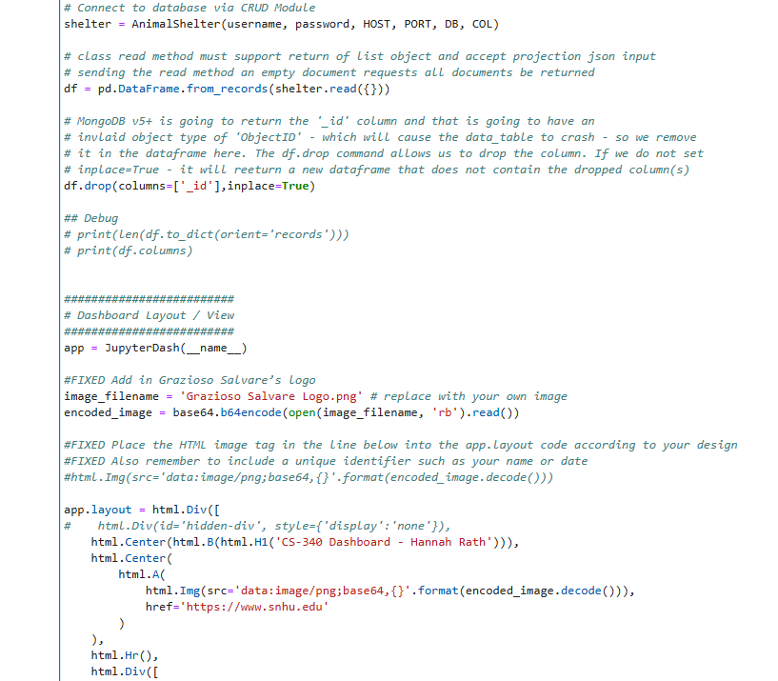

Set up filtering options, in this case a drop-down menu using dcc.Dropdown, with their labels and the values that each selection will point to. Set the default option value to “Reset”.
https://dash.plotly.com/dash-core-components/dropdown
Set up the features for the interactive data table with the table’s permissions.
https://dash.plotly.com/datatable
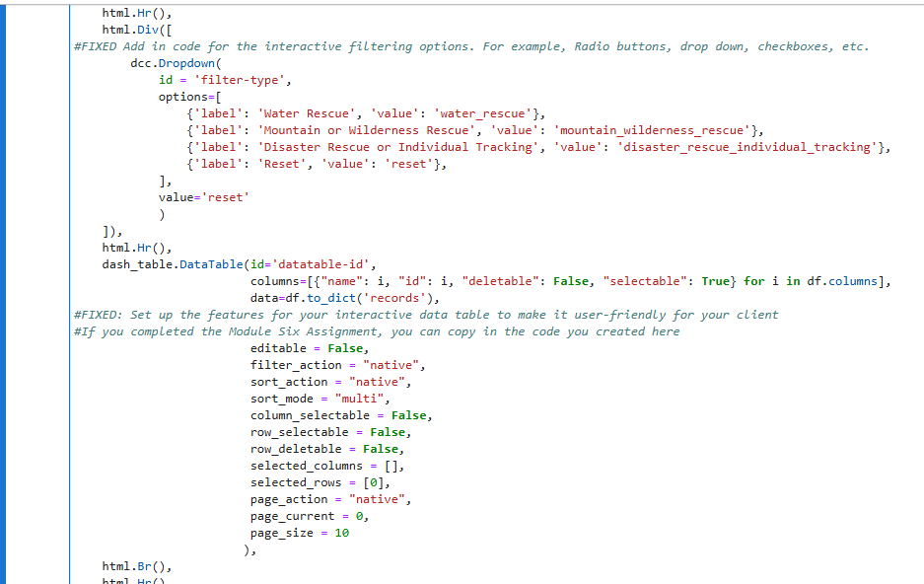

Set up how the charts should be displayed
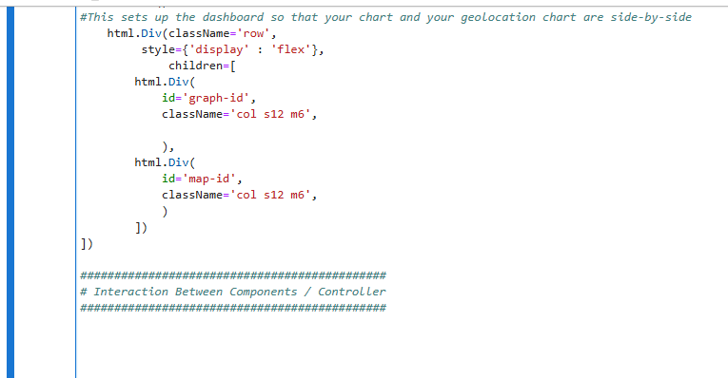

Set the values from the drop-down menu that will show specific criteria for the selected option. Set the reset option to show all items within the database. Run these options through the read function from the Python CRUD Module and display them in the data table.
https://dash.plotly.com/dash-core-components/dropdown
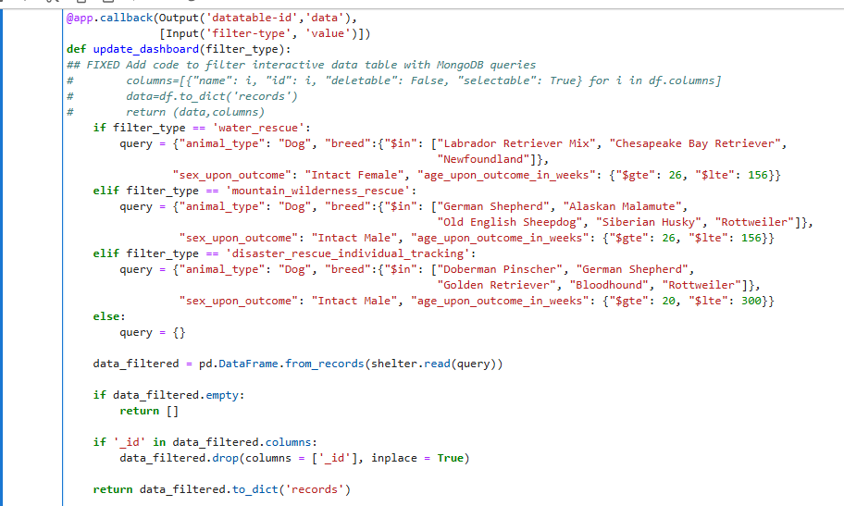

Create a chart, in this case a pie chart, to visualize the results of the drop-down menu selection and data table. https://plotly.com/python/pie-charts/
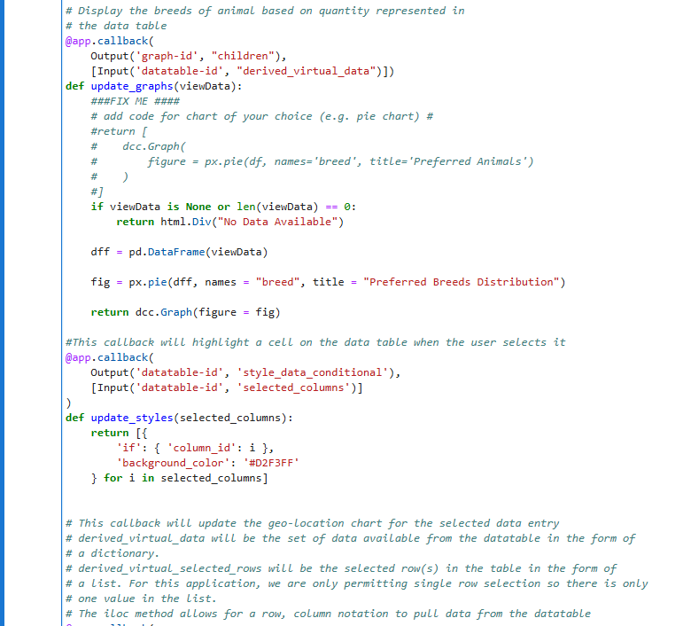
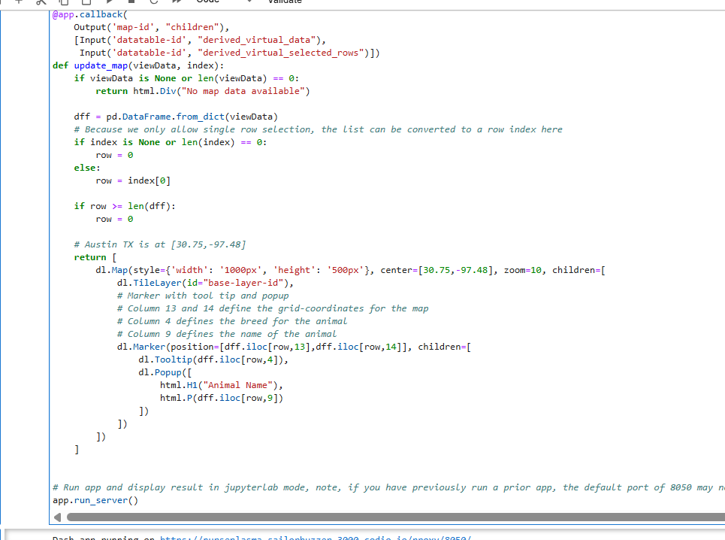

Results
Home page-top
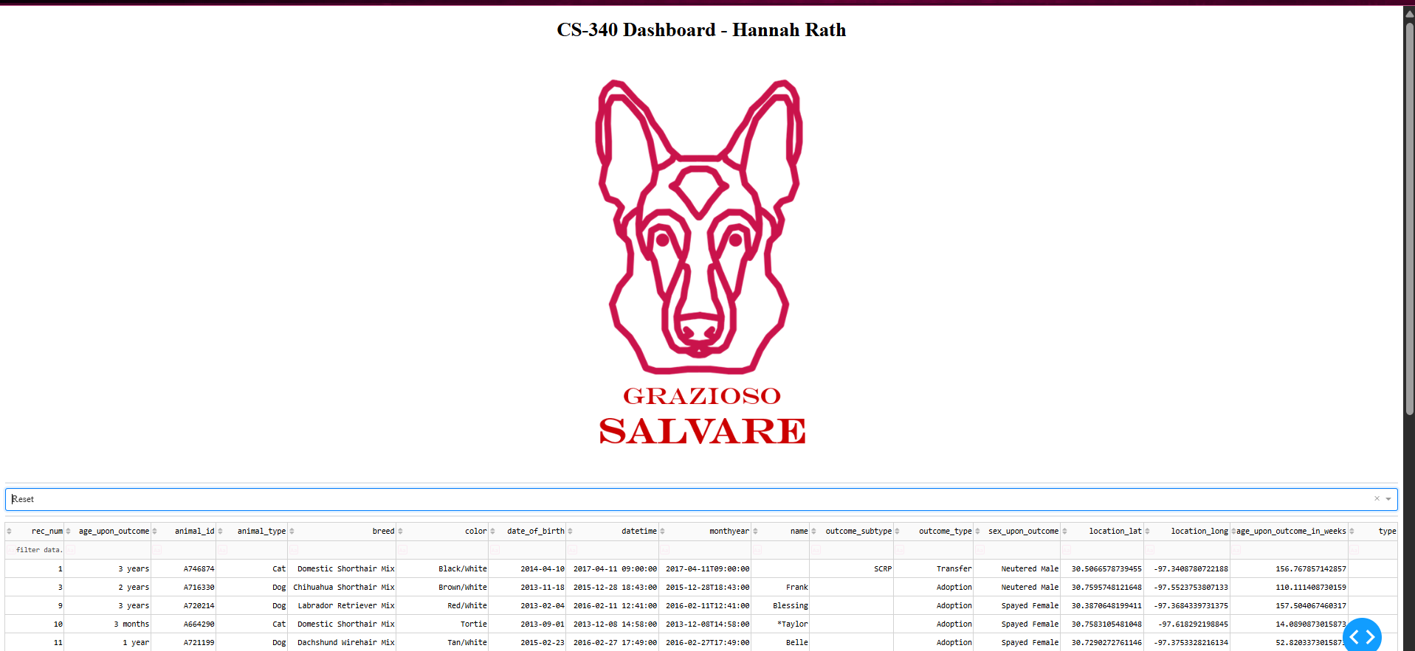

Home page – bottom (Reset option)
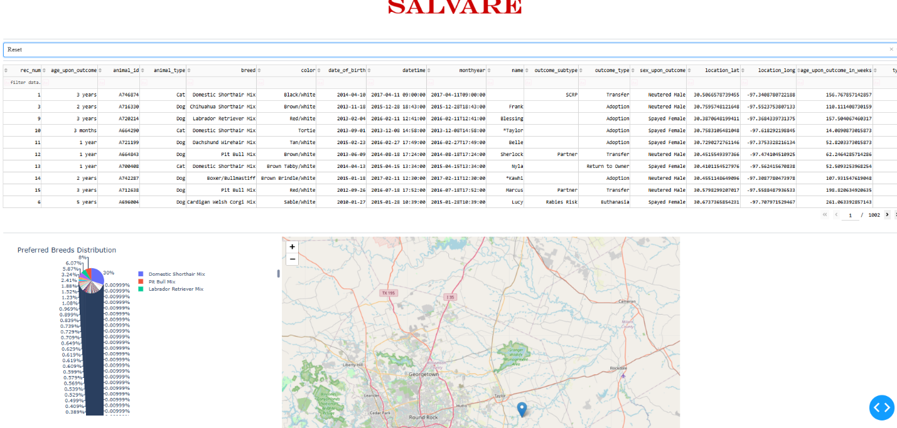

After clicking on the logo the website redirects to www.snhu.edu


Water Rescue option
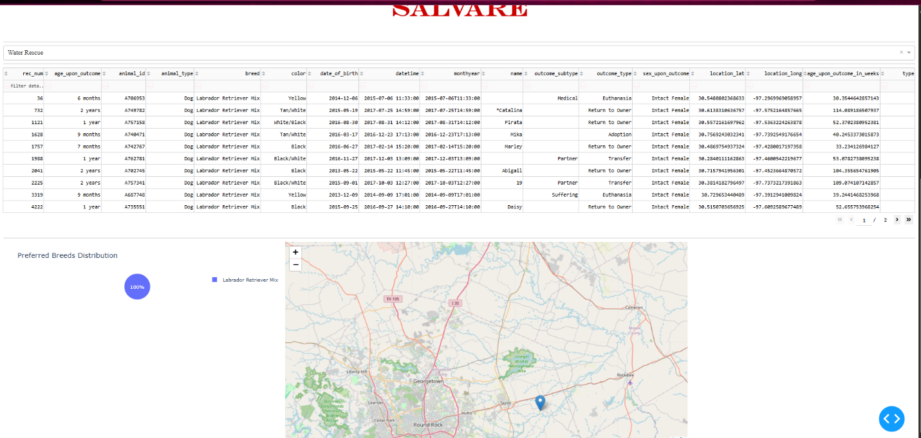

Mountain or Wilderness option
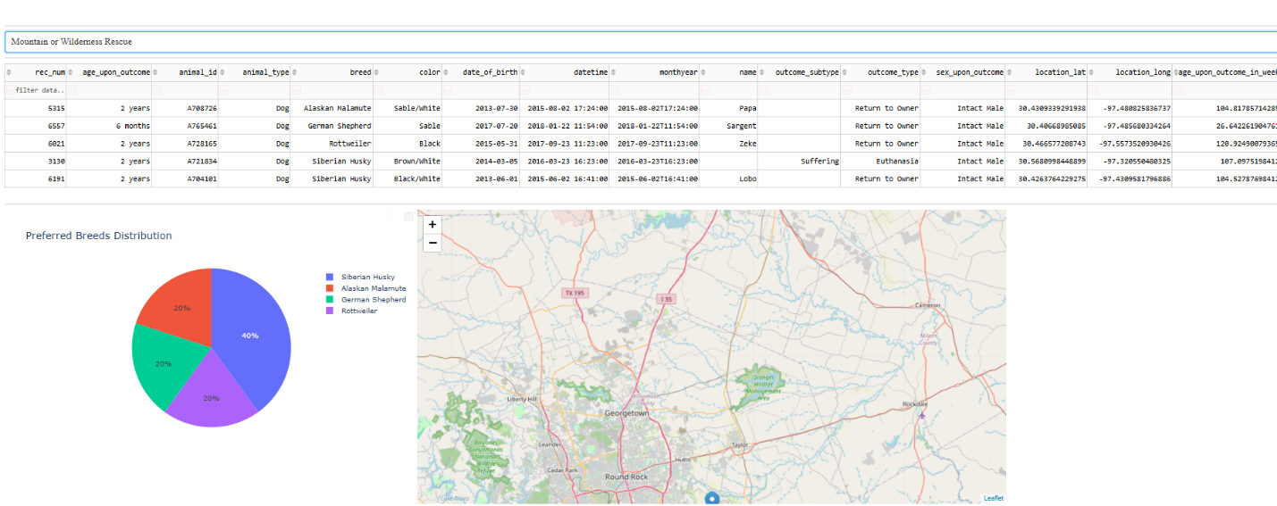

Disaster Rescue or Individual Tracking option
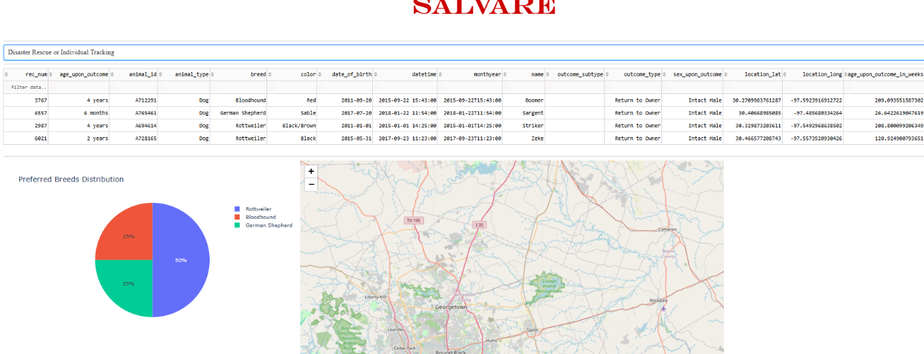

Challenges faced
When developing the dashboard, I had trouble properly incorporating the functionality of the drop-down menu with the specific values that I wanted it to display. I looked at the documentation on https://dash.plotly.com/dash-core-components/dropdown to help me implement it properly, however I kept having errors. Eventually, I found the problem after reading over the code numerous times, it turned out I had syntax errors, specifically, I forgot to add commas between the different criteria inputs, and I used % instead of $ in every one of the values since I copied and pasted each code snippet for each value then slightly edited them based on the specified criteria. It was a simple error, but it took quite a while to find.

Contact
Hannah Rath

